ER Diagram for Messaging System

Group Name: **Super Five**

Group Members:

1. Rahman, Sheikh Talha Jubayer (19-41468-3)
2. Shifat, Mahabub Hasan (19-41460-3)
3. Khanom, Afrida (19-41444-3)
4. Asha, Nahida Akther (19-41190-2)
5. Mim, Syeda Maherunnasha (19-41446-3)

**Case:**

In a Messaging System, a user may or may not have friendship with other users. One user can have zero to many friendships. User is identified by user id. System also stores user name, user date of birth, phone number and address. User can have multiple phone number. Users’ address is composed of city, area and street. Street is also composed of road number and road name. One user can be member of zero to many groups. One group is identified by group id. One group can be created by one or more members. Group has name and group type like entertainments, study and work. System also store group opening date. User can send zero to many messages. One message can be sent by exactly one user. One message is identified by message id. Message has the text and receiver id which is the user id who received this message.

**ER Diagram:**

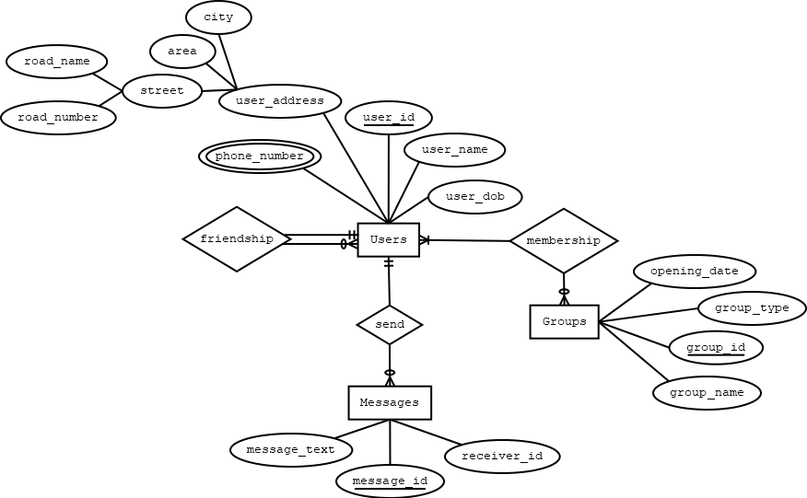

**Normalization:**

**Friendship:**

UNF: 1st: user_id, user_name, user_dob, road_name, road_number, area, city, phone_number, friend_id

1NF: 1st: user_id, phone_number, friend_id, user_name, user_dob, road_name, road_number, area, city

2NF: 1st: user_id, phone_number

2nd: user_id, user_name, user_dob, road_name, road_number, area, city

3rd: user_id, friend_id

3NF: 1st: user_id, phone_number

2nd: user_id, user_name, user_dob, road_number

3rd: road_number, road_name, area, city

4th: user_id, friend_id

**Send:**

UNF: 1st: user_id, user_name, user_dob, road_name, road_number, area, city, phone_number, message_id, message_text, receiver_id

1NF: 1st: user_id, phone_number, message_id, user_name, user_dob, road_name, road_number, area, city, message_text, receiver_id

2NF: 1st: user_id, phone_number

2nd: user_id, user_name, user_dob, road_name, road_number, area, city

3rd: user_id, message_id

4th: message_id, message_text, receiver_id

3NF: 1st: user_id, phone_number

2nd: user_id, user_name, user_dob, road_number

3rd: road_number, road_name, area, city

4th: user_id, message_id

5th: message_id, message_text, receiver_id

**Membership:**

UNF: 1st: user_id, user_name, user_dob, road_name, road_number, area, city, phone_number, group_id, group_name, group_type, opening_date

1NF: 1st: user_id, phone_number, group_id, user_name, user_dob, road_name, road_number, area, city, group_name, group_type, opening_date

2NF: 1st: user_id, phone_number

2nd: user_id, user_name, user_dob, road_name, road_number, area, city

3rd: user_id, group_id

4th: group_id, group_name, group_type, opening_date

3NF: 1st: user_id, phone_number

2nd: user_id, user_name, user_dob, road_number

3rd: road_number, road_name, area, city

4th: user_id, group_id

5th: group_id, group_name, group_type, opening_date

**Final Table:**

1st: user_id, phone_number

2nd: user_id, user_name, user_dob, road_number

3rd: road_number, road_name, area, city

4th: user_id, friend_id

5th: user_id, message_id

6th: message_id, message_text, receiver_id

7th: user_id, group_id

8th: group_id, group_name, group_type, opening_date